

My Top Five Cloud Applications

cloud tools that assist me throughout college

Michaela Healy | Information Technology Year Two | 08/10/2017

Student Number: 20075389

Module: Cloud Computing

Contents

Introduction 2

OneDrive 3

Google Drive 4

LinkedIn 5

SlideShare 5

iCloud 6

Dashlane 7

Conclusion 8

References 9

Table of Figures

Figure 1. Amazon's Cloud Computing Infrastructure 2

Figure 2. My OneDrive Account 3

Figure 3. OneDrive Storage Plans 3

Figure 4. Google Drive Account 4

Figure 5. SlideShare 5

Figure 6. iCloud Account and Apps 6

Figure 7. A Sample Dashlane Account 7

# Introduction

Initially when people say, ‘In the Cloud’ we would think of the sky but nowadays the cloud is a way of storage. Cloud computing allows us to access information if there is internet connection. People may wonder where cloud data is actually stored. Well, it is stored in places sometimes referred to as “server farms” and they are warehouses filled with servers which run all the time.



Figure 1. Amazon's Cloud Computing Infrastructure

Considering the fact, I personally have had terrible experiences which memory sticks, rather it be losing them, breaking them and sometimes them overheating, resulting in me to lose my files/data. Cloud tools are essential to me and have helped and saved me throughout my time in college numerous of times.

I will be talking about my five top cloud applications and how they are beneficial to me throughout my time in college.

# OneDrive

OneDrive is a cloud application which allows students or users to access and upload files as long as they have internet access. When I started in W.I.T. we were automatically given a W.I.T. OneDrive account and they were available on all desktops in the college, so we can access our files. You receive a certain amount of free storage and then you pay for what you use and you can buy more gigabytes of storage to suit your needs. There are many different plans and upgrades available.

In the screenshot it is clear to see that OneDrive is easy to use and practical, as the upload button is easily accessible and I can see all my files and documents clearly and upload more if needed, if I buy more storage.

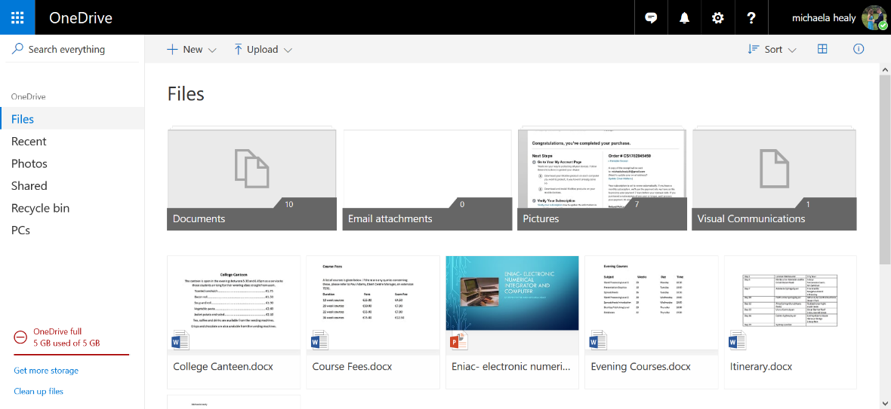

Figure 2. My OneDrive Account

OneDrive is an internet-based storage platform with space offered for free by Microsoft to anyone who has an account. One of the benefits is that OneDrive links into Windows 10. If you log in to a different Windows 10 computing using your Microsoft account you will still have access to your OneDrive data through the web. (Leonhard, 2016).

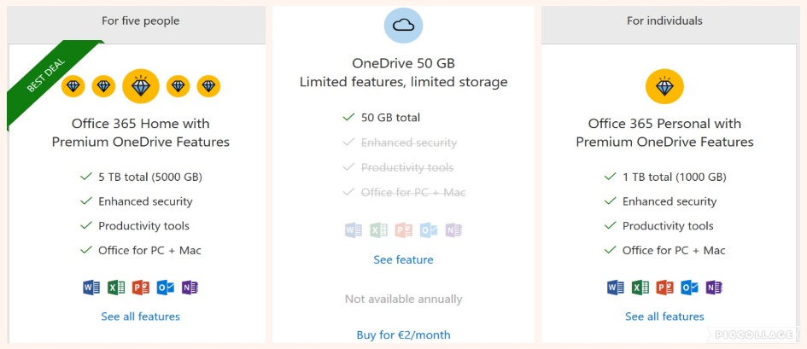

*Figure 3. OneDrive Storage Plans*

# Google Drive

Google Drive is another cloud storage service from Google that allows me and other students/users to access files in college or at home. It can be accessed on numerous devices and I can drag and drop my files into Google Drive, if I’m at home or in college. I can also access them wherever I have Wi-Fi simply by going into my google account. It is very beneficial to students as it is easy to understand and use and it can be accessed easily. You are also given fifteen gigabytes of free storage which is a major bonus.

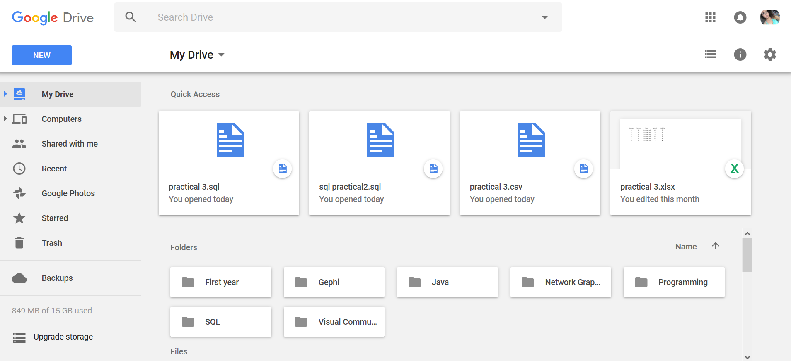

Figure 4. Google Drive Account

In this screenshot, it is clear to see that Google Drive is well presented and easy to follow.

Google Drive started as a virtual space and is usually referred to as “Gdrive” and it is an online and offline storage system with word processing power. You receive the convenience of a virtual folder which we have in college on the computers, that we can store our files in and sync between devices. This means that the files will be downloaded into the folder and uploaded into the cloud any time you make a change. (Karch, 2017)

# LinkedIn

LinkedIn can be considered as an online CV in some cases and anyone can access it with internet access. This is beneficial to me as a student in W.I.T. as when we are applying for work placement or any job, we can simply paste our LinkedIn URL link and we can upload projects we have done to it and it can work as an online portfolio.

LinkedIn is a shared environment that allows managers and professionals from various departments and parts of the world to be in touch with each other. It is also a remarkable job-hunting tool. (McKendrick, 2013)

There is one part of LinkedIn that I find extremely beneficial and helpful throughout college and that is SlideShare.

# SlideShare

SlideShare allows lecturers or anybody to upload slides and anybody can access it. I found myself using SlideShare for notes and studying throughout this year and last year.

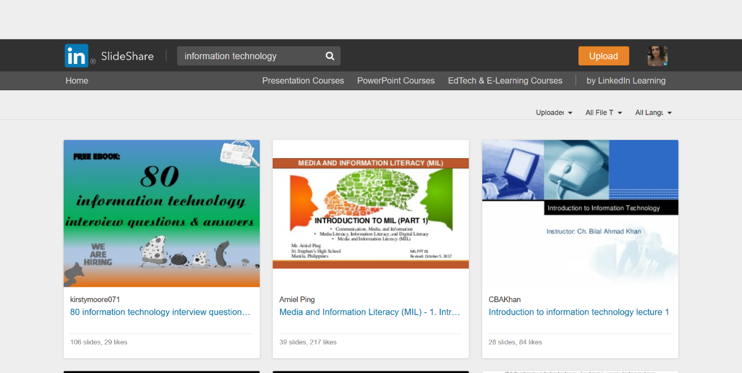

Figure 5. SlideShare

This screenshot shows that you can type in any topic and more than likely you will see results that relate to the requested topic and you will see multiple slides that users have uploaded.

SlideShare is a slide hosting service, obtained by LinkedIn. It allows users to upload files (PowerPoint, PDF and many more). SlideShare is beneficial because it is a low-cost service as there is a both free account option and the option to go pro. (Purvis, 2015)

# iCloud

iCloud is a service provided by Apple that allows me to keep all my devices in sync. If I simply take a photo for an assignment, save a number to my contacts, save a lecturer’s email address, or even take notes in the notepad application that comes with Apple products, I can guarantee that they are all automatically backed up to iCloud and I do not have to worry about manually doing the backups, because I do forget most of the time. I can access any of this data on any Apple device by logging into my Apple account and this is very effective and convenient for me while I am in college. If you log in to iCloud on your computer you get a notification on your device, for example, on an iPhone, that someone in a certain location is logging into your account and you must have a verification code to be able to log in so it is secure.

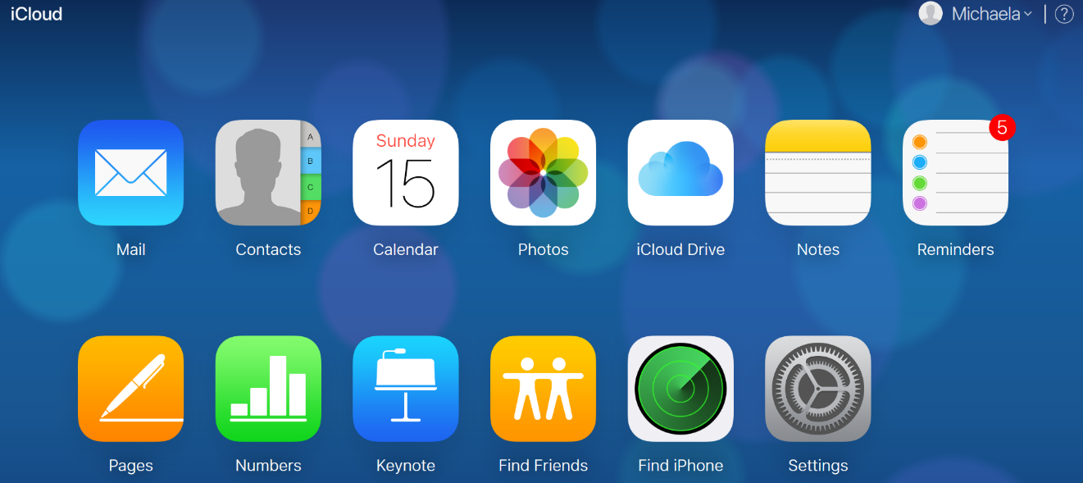

Figure 6. iCloud Account and Apps

In the picture above is my iCloud account and it shows the apps that it has backed up and if I click on any of them I can see all the data that has been backed up for those apps and I can retrieve it, access it, or change it if I desire to do so.

iCloud allows the information on each device to be automatically updated to make sure the most current information is available on all devices. This service is free, operates wirelessly, and runs in the background, with no special action required by the user. (iAnswerGuy, 2016)

# Dashlane

Dashlane is beneficial to me as a student because I almost always forget my passwords and I have different ones for nearly everything. Dashlane is a safe way for me to save my passwords and not have to worry about resetting them everything I forget.

Dashlane also offers a feature to sync and backup files and data across unlimited devices.

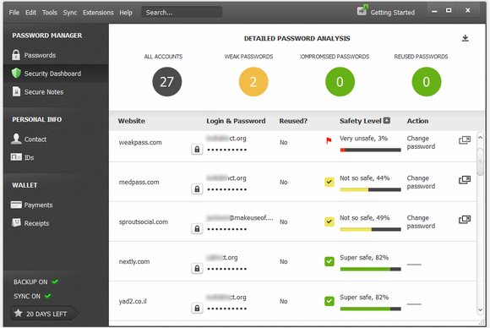

Figure 7. A Sample Dashlane Account

Dashlane is a secure digital memory. You can sync your data to other computers, devices, and access it from anywhere you may need to. (Kite-Powell, 2012) When you are a paid customer you can enable cloud syncs. Dashlane syncs happen every five minutes and can be beneficial as it is certain not to miss any data while it syncs so frequently. (Lancet, 2013)

# Conclusion

In conclusion, cloud applications play a vital role throughout my time in college. Each application has key requirements that I have identified while I have been using them and I find them beneficial for helping me store and backup my data, files, and assignments to the cloud.

The applications I have chosen are practical and easy to use. The only downfall to cloud applications is that internet access is required for the applications to run and work. Other than that, they are an astonishing way to back up files and to make sure all your hard work is in a safe place and is easy to reach. There is no need to be losing files or carrying multiple memory sticks around anymore. Cloud computing has taken over in the best way it possible could.

# References

iAnswerGuy, 2016. *iAnswerGuy.* [Online]   
Available at: http://www.ianswerguy.com/what-is-icloud/  
[Accessed 15 October 2017].

Karch, M., 2017. *Lifewire.* [Online]   
Available at: https://www.lifewire.com/what-is-google-drive-1616234  
[Accessed 15 October 2017].

Kite-Powell, J., 2012. *Forbes.* [Online]   
Available at: https://www.forbes.com/sites/jenniferhicks/2012/02/13/dashlane-is-your-secure-digital-memory/#6c1129d248a5  
[Accessed 15 October 2017].

Lancet, Y., 2013. *PCWorld from IDG.* [Online]   
Available at: https://www.pcworld.com/article/2043301/review-dashlane-is-a-robust-password-manager-with-a-gorgeous-interface.html  
[Accessed 15 October 2017].

Leonhard, W., 2016. *Dummies.com.* [Online]   
Available at: http://www.dummies.com/computers/operating-systems/windows-10/what-is-onedrive/  
[Accessed 15 10 2017].

McKendrick, J., 2013. *Forbes.* [Online]   
Available at: https://www.forbes.com/sites/joemckendrick/2013/03/27/20-most-popular-cloud-based-apps-downloaded-into-enterprises/#7cdb51db3fc8  
[Accessed 15 10 2017].

Miller, R., 2015. *Data Center Frontier.* [Online]   
Available at: https://datacenterfrontier.com/inside-amazon-cloud-computing-infrastructure/  
[Accessed 15 October 2017].

Purvis, D., 2015. *CommsAxis.* [Online]   
Available at: https://www.commsaxis.com/what-how-and-why-to-use-slideshare/  
[Accessed 15 October 2017].